Software development report

Group report

Gisylia Geyoro, Troy Smith, Toby Dustin, Shashank Nehra | engineering software systems | 21 February 2018

Contents

Team Delegation 2

Define job roles and responsibilities (and individual final goals) 2

Belbin self-perception inventory 4

Focus Questions 9

Risk analysis table 11

System requirements 12

Concept maps explained 13

Use case texts 14

User interface 16

Design plan 16

User interface design 17

# Team Delegation

Find the best roles for each team member.

The best way to do this is to use the goals section to find the key skills that are needed then rank team members with their different abilities.

Hierarchy can be used if two team members have the same skill set or a team member doesn’t have any manageable skills

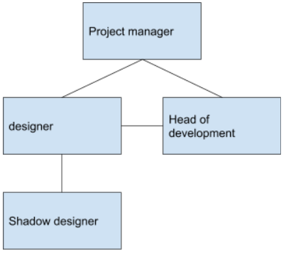

Figure 1 - a basic example of a hierarchy structure for a project with four people

### Define job roles and responsibilities (and individual final goals)

When allocating the team roles, we had first introduced ourselves and had a discussion on our strong points. We had then filled out the Belbin self-perception test and based our results, we had decided to allocate two sets of roles based on both our group discussion and personality test results. the first set is the logical side where we based our roles of what people were comfortable with and the second in terms of our skills and experience.

Front end role allocation

During the group discussion it was discovered that the people most suited to create the front end of the artefact was Gisylia and Troy. This was based on the coding experience of the two and individual preference. Troy was allocated the role of front end coder where he will build the layouts and structure of the artefact, as this is where he felt most comfortable and was his strong point. Whereas Gisylia was tasked with creating and designing the artefacts interface. The reason why she was chosen to create this was based off work she had created in the past as well as the results of her Belbin results

Back end role allocations

Also based off preference and coding experience, Shashank and Toby were tasked with creating the backend and logical side of the artefact. Shashank was tasked with the role of creating all logical codes in the system as well as helping with the backend development. Toby was given the role of database development. Here he oversaw creating the database and ensuring that the artifact will function and run without any issues.

Back end- Toby Dustin

Front end- Troy

Design- Gisylia

logic - Shashank

|  |  |  |  |
| --- | --- | --- | --- |
| **Name** | **Job Role** | **Responsibility** | **Individual Goal** |
| **Gisylia** | **Design (front end) | UI | back end** |  |  |
| **Shashank** | **Logic (back end) API | UI | back end** |  |  |
| **troy** | **Front End (design) | UI | back end** |  |  |
| **toby** | **Back End (logic) | UI | back end** |  |  |

**Plan for failure**

what happens if one of your team fails to meet a target? Who takes over? Make sure that there are at least two people responsible for every task and then as project manager make sure you micromanage each task. The success and failure of this task falls on you as leader, make sure everyone knows what they’re doing and understands the task.

# Belbin self-perception inventory

We had decided to place our Belbin test in one as it was easier to compare the result and conduct the test at the same time.

|  |  |  |  |  |
| --- | --- | --- | --- | --- |
|  | **Troy** | **Gisylia** | **Shashank** | **Toby** |
| I think I can quickly see and take advantage of new opportunities | **7** | **7** | **7** | **10** |
| I can work well with a very wide range of people. | **8** | **9** | **9** | **10** |
| Producing ideas is one of my natural assets. | **9** | **8** | **7** | **10** |
| My ability rests in being able to draw people out whenever I detect they have something of value to contribute to group objectives. | **4** | **3** | **5** | **10** |
| My capacity to follow through has much to do with my personal effectiveness | **4** | **5** | **5** | **10** |
| I am ready to face temporary unpopularity if it leads to worthwhile results in the end | **7** | **4** | **8** | **10** |
| I am quick to sense what is likely to work in a situation with which I am familiar | **7** | **7** | **8** | **10** |
| I can offer a reasoned case for alternative courses of action without introducing bias or prejudice | **6** | **5** | **5** | **10** |

**II. If I have a possible shortcoming in teamwork, it could be that:**

|  |  |  |  |  |
| --- | --- | --- | --- | --- |
|  | **Troy** | **Gisylia** | **Shashank** | **Toby** |
| I am not at ease unless meetings are well structured and controlled and generally well conducted | **8** | **10** | **9** | **10** |
| I am inclined to be too generous towards others who have a valid viewpoint that has not been given a proper airing. | **9** | **8** | **8** | **10** |
| I have a tendency to talk a lot once the group gets on to new ideas | **5** | **6** | **5** | **10** |
| My objective outlook makes it difficult for me to join in readily and enthusiastically with colleagues. | **3** | **2** | **7** | **10** |
| I am sometimes seen as forceful and authoritarian if there is a need to get something done. | **3** | **2** | **7** | **10** |
| I find it difficult to lead from the front, perhaps because I am over responsive to group atmosphere. |  | **3** | **7** | **10** |
| I am apt to get too caught up in ideas that occur to me and so lose track of what is happening. | **5** | **6** | **7** | **10** |
| My colleagues tend to see me as worrying unnecessarily over detail and the possibility that things may go wrong. | **5** | **5** | **7** | **10** |

**III. When involved in a project with other people:**

|  |  |  |  |  |
| --- | --- | --- | --- | --- |
|  | **Troy** | **Gisylia** | **Shashank** | **Toby** |
| I have an aptitude for influencing people without pressurising them. | **7** | **9** | **7** | **10** |
| My general vigilance prevents careless mistakes and omissions being made. | **5** | **6** | **7** | **10** |
| I am ready to press for action to make sure the meeting does not waste time or lose sight of the main objective | **8** | **8** | **7** | **10** |
| I can be counted on to contribute something original. | **7** | **7** | **7** | **10** |
| I am always ready to back a good suggestion in the common interest. | **9** | **8** | **7** | **10** |
| I am keen to look for the latest in new ideas and developments | **8** | **7** | **7** | **10** |
| I believe my capacity for cool judgement is appreciated by others. | **7** | **6** | **7** | **10** |
| I can be relied upon to see that all essential work is organised. | **9** | **10** | **7** | **10** |

|  |
| --- |
| **IV. My characteristic approach to group work is that:** |
|  | **Troy** | **Gisylia** | **Shashank** | **Toby** | |
| I have a quiet interest in getting to know colleagues better. | **8** | **10** | **7** | **10** | |
| I am not reluctant to challenge the views of others or to hold a minority view myself. | **7** | **5** | **7** | **10** | |
| I can usually find a line of argument to refute unsound propositions. | **5** | **5** | **7** | **10** | |
| I think I have a talent for making things work once a plan has to be put into operation. | **7** | **7** | **7** | **10** | |
| I have a tendency to avoid the obvious and to come out with the unexpected. | **7** | **8** | **7** | **10** | |
| I bring a touch of perfection to any team job I undertake. | **8** | **10** | **7** | **10** | |
| I am ready to make use of contacts outside the group itself. | **7** | **8** | **7** | **10** | |
| While I am interested in all views I have no hesitation in making up my mind once a decision has to be made. | **8** | **9** | **7** | **10** | |
| **V. I gain satisfaction in a job because:** |
|  | **Troy** | **Gisylia** | **Shashank** | **Toby** | |
| I enjoy analysing situations and weighing up all the possible choices | **7** | **8** | **7** | **10** | |
| I am interested in finding practical solutions to problems. | **8** | **9** | **7** | **10** | |
| I like to feel I am fostering good working relationships. | **7** | **8** | **7** | **10** | |
| I can have a strong influence on decisions. | **7** | **7** | **7** | **10** | |
| I can meet people who may have something new to offer. | **7** | **9** | **7** | **10** | |
| I can get people to agree on a necessary course of action. | **8** | **8** | **7** | **10** | |
| I feel in my element where I can give a task my full attention. | **9** | **9** | **7** | **10** | |
| I like to find a field that stretches my imagination. | **8** | **8** | **7** | **10** | |
| **VI. If I am suddenly given a difficult task with limited time and unfamiliar people:** | | | | |
|  | **Troy** | **Gisylia** | **Shashank** | **Toby** | |
| I would feel like retiring to a corner to devise a way out of the impasse before developing a line. | **7** | **9** | **7** | **10** | |
| I would be ready to work with the person who showed the most positive approach, however difficult he might be. | **8** | **9** | **7** | **10** | |
| I would find some way of reducing the size of the task by establishing what different individuals might best contribute. | **7** | **8** | **7** | **10** | |
| My natural sense of urgency would help to ensure that we did not fall behind schedule. | **8** | **9** | **7** | **10** | |
| I believe I would keep cool and maintain my capacity to think straight. | **7** | **9** | **7** | **10** | |
| I would retain a steadiness of purpose in spite of the pressures. | **8** | **9** | **9** | **10** | |
| I would be prepared to take a positive lead if I felt the group was making no progress. | **7** | **8** | **9** | **10** | |
| I would open up discussions with a view to stimulating new thoughts and getting something moving. | **8** | **9** | **9** | **10** | |

|  |
| --- |
| **VIIWith reference to the problems to which I am subject in working in groups:** |

|  |  |  |  |  |
| --- | --- | --- | --- | --- |
|  | **Troy** | **Gisylia** | **Shashank** | **Toby** |
| I am apt to show my impatience with those who are obstructing progress. | **7** | **8** | **9** | **10** |
| Others may criticise me for being too analytical and insufficiently intuitive. | **7** | **9** | **9** | **10** |
| My desire to ensure that work is properly done can hold up proceedings. | **8** | **8** | **9** | **10** |
| I tend to get bored rather easily and rely on one or two stimulating members to spark me off. | **8** | **8** | **9** | **10** |
| I find it difficult to get started unless the goals are clear. | **8** | **6** | **9** | **10** |
| I am sometimes poor at explaining and clarifying complex points that occur to me. | **8** | **9** | **9** | **10** |
| I am conscious of demanding from others the things I cannot do myself. | **7** | **9** | **9** | **10** |
| I hesitate to get my points across when I run up against real opposition. | **7** | **7** | **9** | **10** |

# Focus Questions

**What is the main use of the system?**

The main use of the system is to give customers (individuals or companies who want a job doing) to be able to hire staff members (individuals or companies) that can complete that service, also giving the customer the option to repeat the service and gives them the information they need. Also, it allows for staff members to send communications with customers, view navigational maps and complete tasks, even on mobile devices.

**Why should the system exist?**

The system should exist because it makes finding jobs for workers as well as solving problems for customers.

**Who is the system helping?**

The system is helping individuals and companies to complete cleaning and maintenance issues without making too much effort.

**How does a customer use the system?**

The customer will register with the system, login with the system, and then will be able to add properties to the system and add tickets to the properties.

**What can a customer do on the system?**

The customer can add property details to the system, which then become their properties and the property information as well as other information on the system.

**How does a staff member use the system?**

Staff members do NOT need to register with the system as the Admin on the system will add there information to the system, the staff will be able to login and see any open tickets, also with a press of a button they will see archived tickets and data about they’re service.

**What can a staff member do on the system?**

Staff members will be able to look at open tickets on the system, look at archived tickets and look at data about they’re service

**How will staff members communicate with the customers?**

Staff members will be able to email customers using their own email clients, making sure that they can sign off with their own signatures as well as including information about the completed job.

**Who is the system for?**

The system is for companies and individuals who are looking for maintenance services.

**What is the demographics of the user base?**

The demographic of the system will range, the system will have no age limit except for complying with the Malicious Communications Act 1988 and the Communications Act 2003 Section 127

**When can you use the system?**

You can use the system at any time however, services may be unavailable at later times

**Where can you use the system?**

You can use the system everywhere you have an internet connection, whether that be with WiFi or mobile data.

**Why should users use this system instead of using a different solution?**

Our system is the cleanest and simplest to use, we can create a simple environment for our customers as well as our staff, also for staff, our system allows them to create reports and generating real time charts and data.

**Who can use the system?**

Anyone with an internet connection and a web browser.

**How will the system work?**

The system will use MYSQL and PHP as a back end and HTML/CSS/JS front end. The system will store the data in a database and then display the data when requested.

**What technology will be used?**

PHP, MYSQL, HTML, CSS, JS

**Will new technology have to be used to make the system work?**

No

**What requirements are needed for the system to work?**

A web browser and an internet connection

**If the system is on a different device, such as a mobile, how will the system differ?**

The system will not change on other devices.

**Who will maintain the system?**

The administrators of the system

**How can the system be adapted in the future?**

The system can be updated to add payments, correct timing and even invoice tracking

**Will the system survive into the future? (future proofing)**

yes.

# Risk analysis table

|  |  |  |  |  |  |  |  |
| --- | --- | --- | --- | --- | --- | --- | --- |
| **ID** | **Risk Event Description and Impact Area** | **Impact Score** | **Probability Score** | **Risk Score** | **Overall Risk Level** | **Risk Response Description** | **Trigger** |
| 1 | Client Requirements- risks include the client changing the requirement of the project later. | Low | Low | 4 | Low | Implement a change plan to standardize how the team will handle the change requirements | Client Changes requirements for project |
| 2 | Maintenance- not being able to maintain the project after completion | High | High | 1 | High | Implement preventative/perfective maintenance to ensure the detection of any latent faults in the software and correct them before they become effective faults | lack of testing and updates to the project |
| 3 | Testing – risks include availability of application test resources, schedule | Low | Low | 4 | Low | Ensure that the team is not behind on the schedule leading to the testing being rushed | Team behind on schedule |
| 4 | Design- risks include design not matching client requirements | Low | High | 3 | Medium/low | Ensure that the team has clear understanding of design requirements for this project | client does not agree with the design. |
| 5 | Implementation- risks include: failure of functionality and performance | High | Low | 2 | Medium/High | Peer review functionality and performance done by each individual character, and give feedback | Functionality does not meet the clients requirement |
| 6 | Team Conflict- risks include harmony within the team, making productivity low | Low | Low | 4 | Low | Have weekly meetings to discuss and review individual tasks done by each other and give constructive feedback | Behind on the project overall, lack of communication |

# System requirements

As our project is web based an internet connection is required but we developed the webpage to be very easy on bandwidth, this means that an internet connection of 1mb per second will be sufficient to use our system.

As for accessing the system it is required that the accessing party has a web browser that allows for some HTML5 and CSS3 elements to be rendered, web browsers that have this capability are Google Chrome, Safari, Chromium, Firefox, and Edge, it’s a good idea to stay away from older browsers such as Internet Explorer and Netscape.

Finally, the biggest system requirement would be some sort of house or property to service, as this is required to be able to use the system. You cannot use a property maintenance system if you don't have a property to maintain.

# Development Methodology

As a team we decided to use the waterfall methodology because the clients requirements were very clear and we were using familiar development tools and this methodology followed the structure of the project development life cycle with different sequences each representing the 7 different stages of the product development life cycle and this was the best way to approach our project because in the waterfall methodology it made sense to follow due to each stage having specific tasks to complete for each team member to complete and deliver throughout each stage.

The waterfall methodology allowed the allows the team to make sure each after each requirement is completed at a high level because you cannot move on to the next stage without finishing the stage that you are currently on.

The requirements and planning stage in the waterfall method allows the team to have a detailed and robust design structure for our project which would be due to the project initiation and planning stage. Using the waterfall methodology also allows the team to make early alterations to the design, development, and implementation and testing, also due to the structure being very organized of this methodology it means that our team will be very disciplined in each stage.

This method is also suited to our type of project with several different milestones to reach in a certain amount of time on each stage to make sure that everything is on track, this is due to the structure of the waterfall methodology being very clear, making it easy for the team to understand and prepare for.

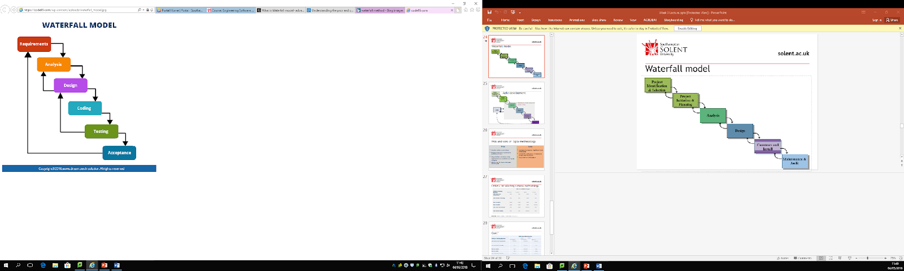

# Concept maps explained

1.   Clients subscribing to the company’s service can be individuals or organisation.

Clients can be individual or organisation

2.      A single client can be associated with multiple services i.e.; one client can have more than one property under their control

1 client n properties

1 property n services

3.      Different cleaning service are available including gardening, window cleaning etc., therefore; clients will have to subscribe to package(s) that offer the service they subscribe.

Ticket -> Packages -> [Services, repeat]

4.      Clients will have an electronic update and possibly, notification of service(s) completed for them. For example, date and time of service, type of service, next service due etc.

Email update-> when ticket complete

5.      Services’ frequencies can range from one-off, daily, weekly, monthly, etc.

6.      Details of payments of services completed should be recorded (This does not have to be a working payment system; it is just to demonstrate a completed service)

7.      A booking system for clients which allow clients to request service(s) whenever they are available

8.      Due to a high demand for services, jobs will have to be allocated to staffs based on their availability to meet demands.

# Use case texts

Client Login

|  |  |
| --- | --- |
| User | System |
| Enters username into input field | - |
| Enters password into input field | - |
| Clicks ‘login’ button | - |
|  | Username and password POST request sent to server |
|  | Password is formatted in SHA512 |
|  | Username and password are used in SQL script to find corresponding row |
|  | Session started with token given |
|  | Dashboard page loads |

Client register

|  |  |
| --- | --- |
| User | System |
| User fills out registry form and clicks submit | - |
|  | All details are sent via POST request. |
|  | Password is formatted in SHA512 |
|  | All fields are inserted into the database |

Client view property / view tickets

|  |  |
| --- | --- |
| User | System |
| Client selects location of interest | - |
|  | System loads all tickets off the property that is clicked on by user, by sending the location ID to the search term on database |
|  | System then produces styled ticket information with the data pulled from the database |

Client add ticket

|  |  |
| --- | --- |
| User | System |
| Client selects the add ticket function on the system | - |
| - | System brings up form for insert |
| Client fills out form to insert ticket | - |
| - | System sends information to the server page |
| - | System runs algorithm to staff information |
| - | System inserts new ticket to the database |

Client delete ticket

|  |  |
| --- | --- |
| User | System |
| Client presses ‘cancel’ button on top of ticket | - |
| - | System upgrades data with a complete of 2, meaning ‘cancelled’. |

Client delete ticket

|  |  |
| --- | --- |
| User | System |
| Client presses ‘cancel’ button on top of ticket | - |
| - | System upgrades data with a complete of 2, meaning ‘cancelled’. |

# User interface

### Design plan

Home page

* Images should be placed at the top of the screen with a slide show
  + This is a very generic design aspect, but it is also a very nice layout
* The colour scheme should be based around greens and reds
  + The colours should have relevance to the concept as well as the logo colour
  + There should be clear defining colours that outline important areas of headers
  + The colours should be on the same spectrum allowing easy eye transitions
* There should be quotes on the images from previous customers that
  + The images are static and will not change
* At the bottom of the page is an easy access menu to different pages and contact info

Sign up page for employees

 The colour scheme will be shades of red

* + Not harsh reds but soft autumn colours
  + Varying from reds to yellows

Sign up for customers

* Customers will follow the green colour scheme
  + They will be signing up through the website so the colour should be like the home page

 Design elements on both pages

1. The reason the sign-up pages are different colour is to show the differences between where the customers go and where the staff go
2. Design element a bookmark on the outside of the webpage will also help distinguish the two groups
3. The sign-up options will be placed in the center if the page
4. The fonts type and sizes will be the same for both

Sign in

 The colours will match the user’s area so customers will have greens and blues whilst the staff will have reds

* Following the same design as the sign-up page the only difference is the amount of text boxes that will appear

  Colour scheme

 The colour scheme was based on the importance of items on the page. Matching the logo eyes are automatically drawn to elements with similar shades and pigments. This way user will automatically view promotions/ important areas of the webpage quicker. After conducting research on different webpage layouts, I have decided to design the website in a modern style. using a softer creamier white colour, the difference between different areas will be subtle but noticeable to the trained eye.

### User interface design

* Sign in page for both staff and customer

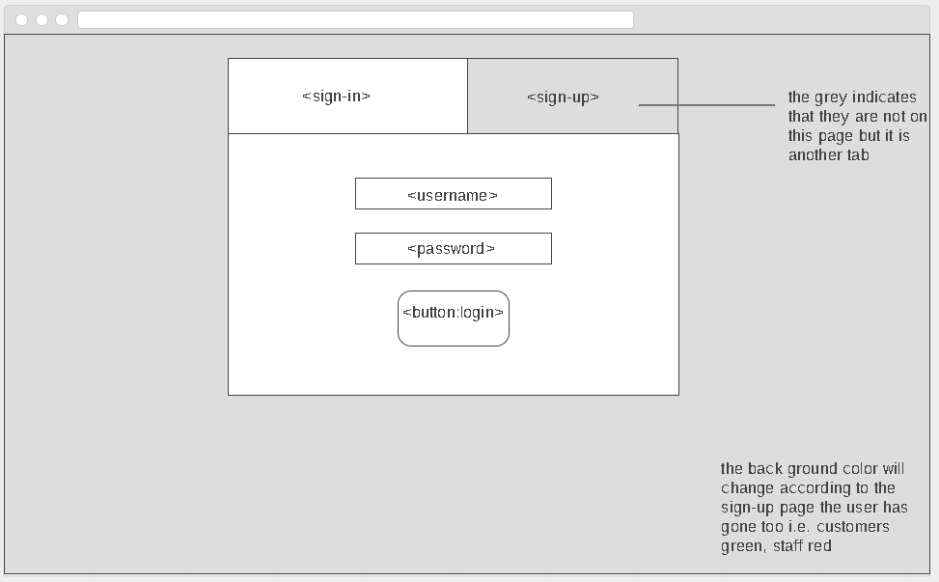

* Sign up page for both staff and customer

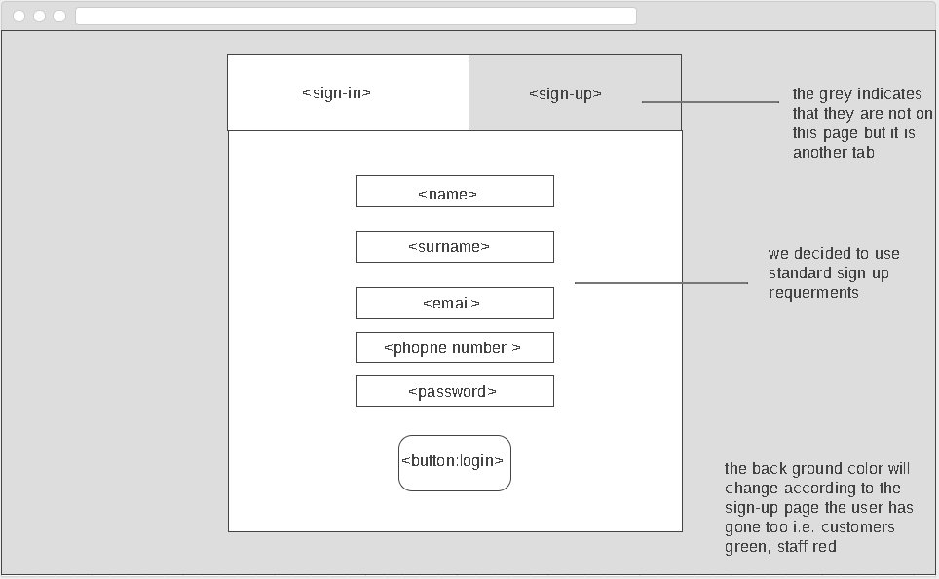

* Home page

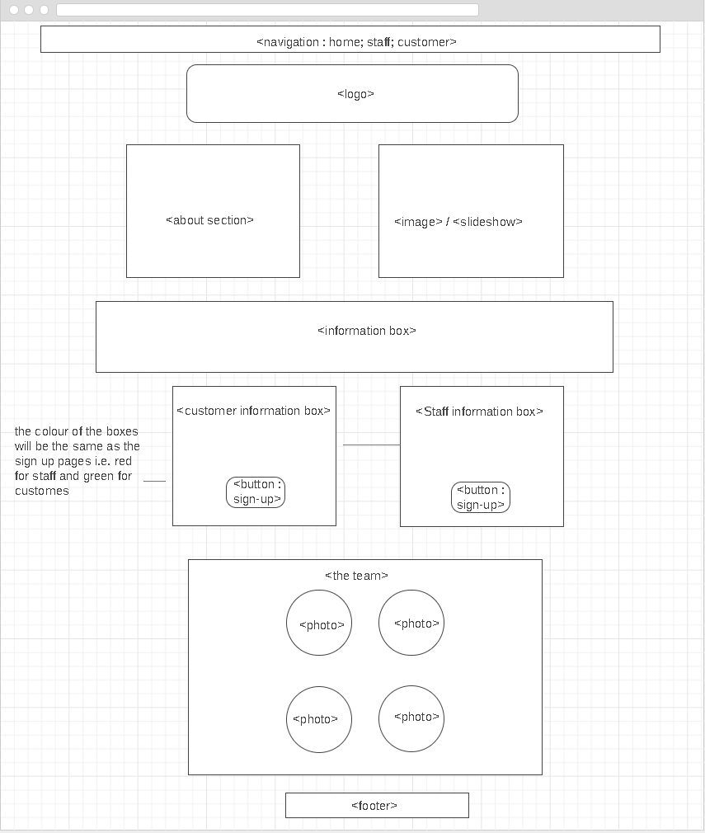

* Customer dash board

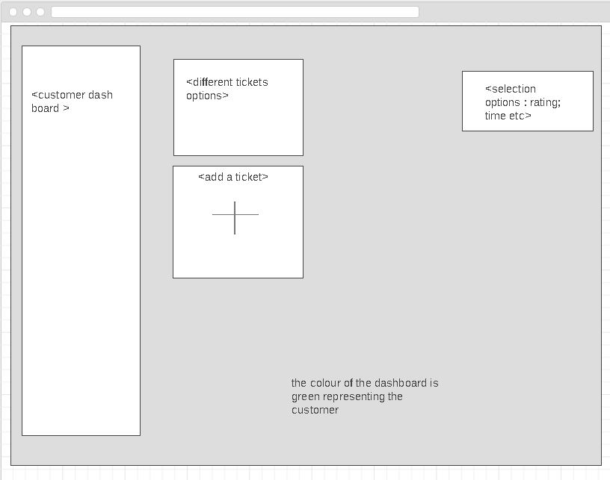

* Staff dashboard

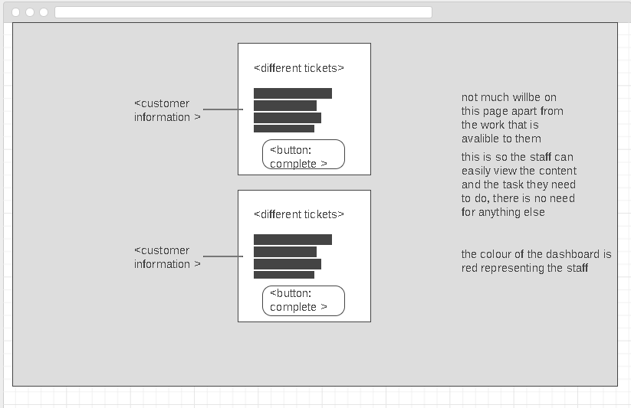

# Tools of version control and Communication

Git hub

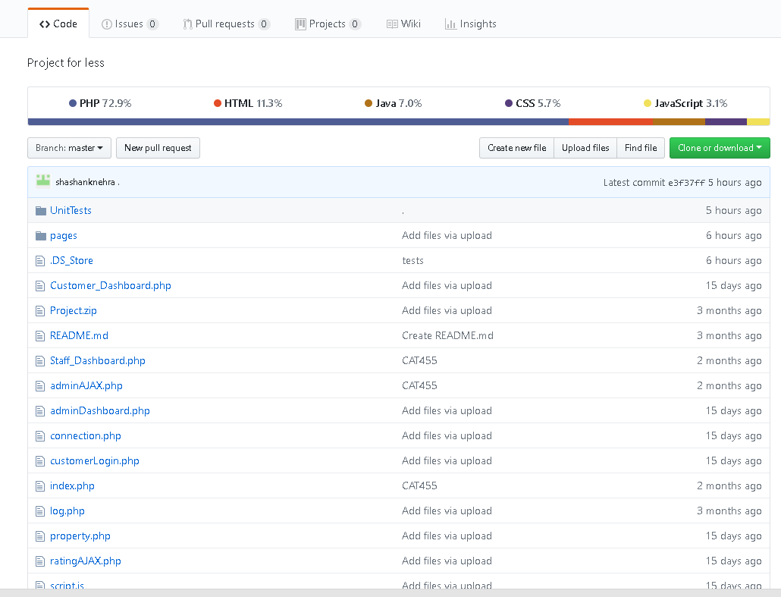

Trello

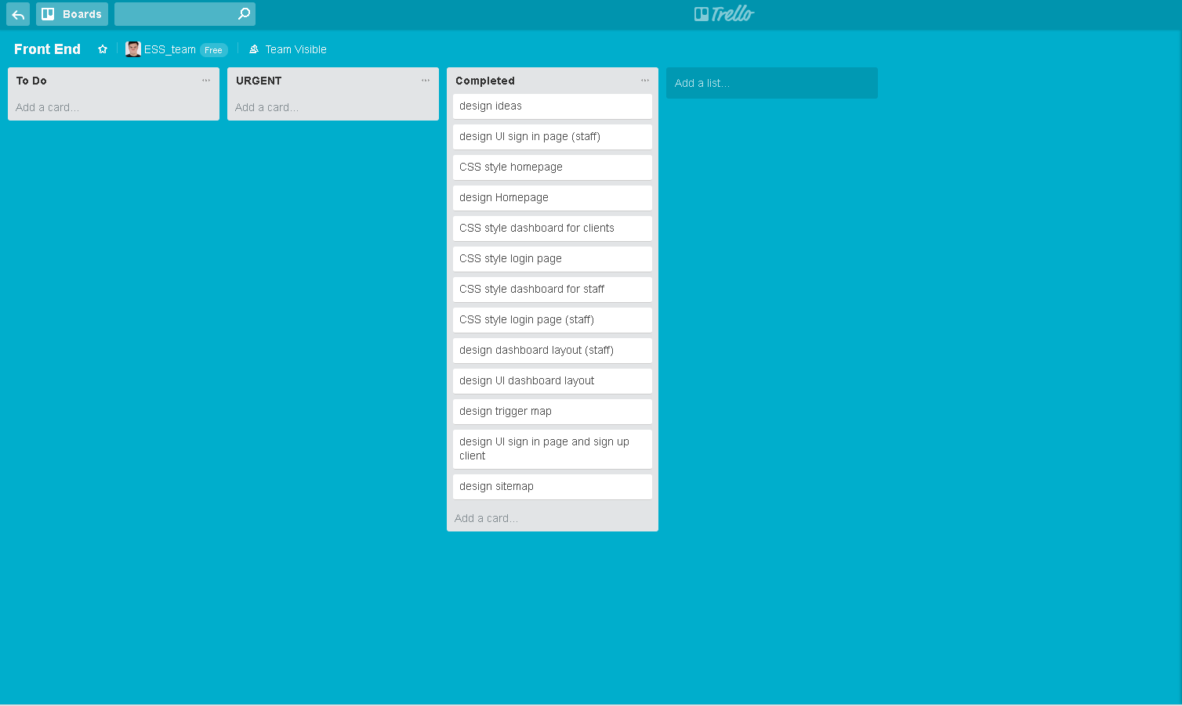

Microsoft OneNote

